*Note: In the interview I was not allowed to take the question paper back to the home, however I remember those questions from my brain. I will recall and rewrite AS MUCH AS POSSIBLE. My Experience about the interview is on the last page.*

**Instructions:**

1. The programming language of your choice is C or C++ or Java.
2. For Developing in C and C++ you are provided with Dev C++.
3. For Developing in Java, you are provided with NetBeans and Eclipse IDE.
4. Create a folder with your name and department which you are coming from. Example: VISWESWARAN_CSE. Your source code should be contained in that folder.
5. The maximum duration is 3 hours.
6. Total programming problems is 6.

**Question 1 – String replacement:**

In this question you will be needed to get a string as an input from the user.

Example Input:

Java123

The repeated characters should be replaced with next characters. i.e. Javb123

*Note: The string replacement should be case sensitive.*

**Example Input:**

MalAyalam999

**Example Output:**

MalAybmcm91011

**Question 2 – Palindrome Checker:**

Check whether the given string is a palindrome or not. For example: Malayalam and predict all possible palindrome outcome.

~~~~ NEXT QUESTIONS ALONG WITH ANSWERS YET TO BE UPDATED. WHENEVER I FIND TIME WILL UPDATE ~~~~

**Personal Experience about the interview:**

**Pros:**

1. The time you need to be present on the hall is 9:00 A.M but is not so strict, I’ve seen candidates entering an hour later. But make sure you present on the given time else you will have insufficient time to solve the programming problems.
2. You will be given a temporary identity card after filling an e-form (with photo of you taken by them using their web-cam). The identity card will be like this,

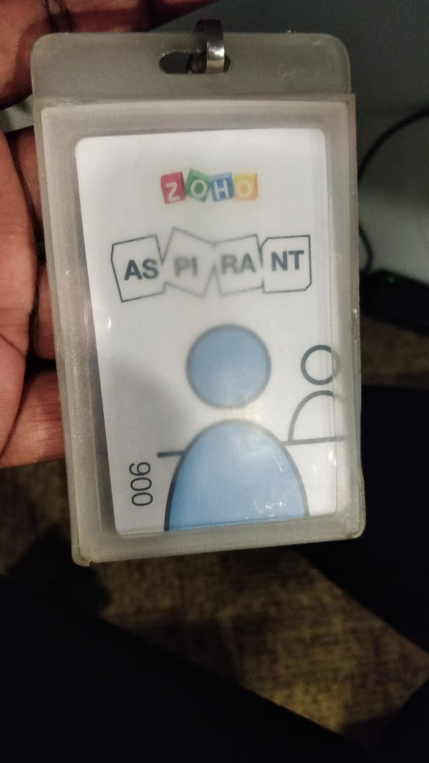

1. Amazing environment and workplace, nobody questions you if you wear the above identity card. I just roamed some places like gym, canteen, etc.,
2. At 09:30 the programming round will start, the laptops given to us at the time of our programming round was DELL Latitude model, i7 processor with all goodness for solving the problems in Java and C++. (Windows 10 of-course).
3. 6 questions will be given and you need to attend at least three.
4. External wired mouse for the laptop is provided.

**Cons:**

1. Although, the laptop model which is provided is high-end; the screen size is pretty much smaller so if you are used to work with a professional desktop and other laptops with standard screen size you will find it difficult for the following reasons.
   1. Unlike other standard keyboard there won’t be any space between the keys of the keyboard as the model size is small. If you are used with mechanical and other standard keyboards like Logitech K345 you need to be careful as you will accidently hit two keys at a time and you can’t handle it rough like a mechanical keyboard. 3 hours is quiet an insufficient time so it is natural to hit the keyboard harder due to adrenaline rush. You can’t do it here.
   2. I personally had a severe head ache due to immense watching of the small sized screen.
2. There is no open explanation or ranking system, they will say to hand over the resume to the candidates who had done something in the programming round. Some candidates left after reading the question paper but that is none of our concern here. So, they will have a fewer resumes now, but IDK how they are grading the candidates. Nobody in the hall is graded IDK how they will find out who performed well and who didn’t without grading. It would have been nicer if the challenge is conducted on hacker rank as it has a ranking system me and other candidates who attended the interview would have known their performance.
3. You will loose peace due to fear of shortage of time and a minor bug will end up in a major environment overall it is like a horse race or like a battle-ground.